# Name: Yash Sasane Roll no: 681 PRN: 202201050052 Division: F(F4)

EDS Assignment 6:

|  |
| --- |
| import numpy as nm |
| import matplotlib.pyplot as mtp |
| import pandas as pd |
| data_set=pd.read_csv('/content/sample_data/Salary_Data (1).xls') |
| data_set |

Output:

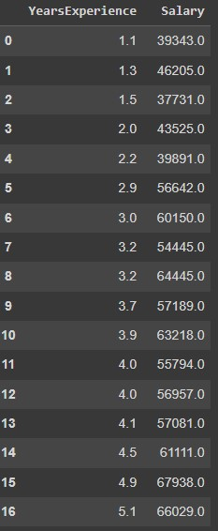

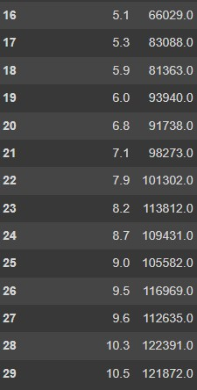

|  |
| --- |
| x=data_set.iloc[:,:-1].values |
| y=data_set.iloc[:,1].values |
| #splitting the dataset into training and test set |
| from sklearn.model_selection import train_test_split |
| x_train, x_test, y_train, y_test=train_test_split(x,y,test_size=1/3,random_state=0) |
| print(x_train) |

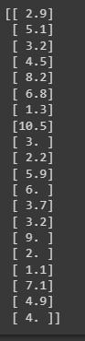

|  |
| --- |
| #fitting the simple linear regression model to the training dataset |
| from sklearn.linear_model import LinearRegression |
| regressor=LinearRegression() |
| regressor.fit(x_train, y_train) |
|  |
|  |



|  |
| --- |
| #prediction of test and training set result |
| y_pred= regressor.predict(x_test) |
| x_pred= regressor.predict(x_train) |
| print(y_pred) |



|  |
| --- |
| mtp.scatter(x_train, y_train, color="green") |
| mtp.plot(x_train, x_pred, color="red") |
| mtp.title("salary vs") |

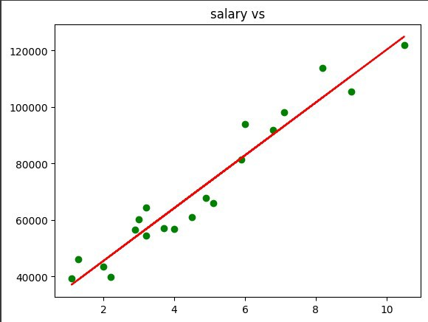

|  |
| --- |
| mtp.scatter(x_train, y_train, color="green") |
| mtp.plot(x_train, x_pred, color="red") |
| mtp.title("Salary vs Experience(Training Dataset)") |
| mtp.xlabel("Years of Experience") |
| mtp.ylabel("Salary(In Rupees)") |
| mtp.show |

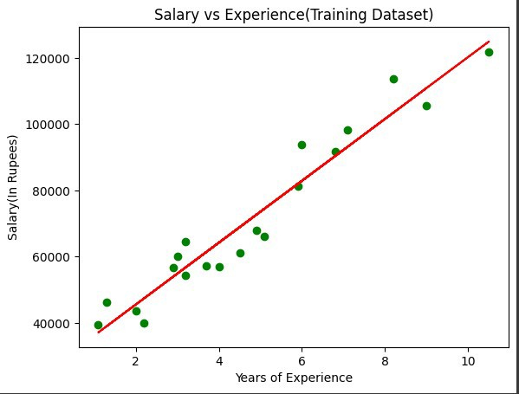

|  |
| --- |
| #visualising the test set result |
| mtp.scatter(x_test, y_test, color="blue") |
| mtp.plot(x_train, x_pred, color="red") |
| mtp.title("salary vs experience") |
| mtp.xlabel("years of experience") |
| mtp.ylabel("salary (in rupees)") |
| mtp.show() |

